**OOA using UML**

Consider the following problem description: A mail-order company wants to automate its

order processing. The initial version of the order processing system should be accessible

to customers via the web. Customers can also call the company by phone and interact

with the system via a customer representative. It is highly likely that the company will

enhance this system in upcoming years with new features. The system allows customers

to place orders, check the status of their orders, cancel an existing order and request a

catalog. Customers may also return a product but this is only possible through the phone,

not available on the web. When placing an order, the customer identifies himself by

means of customer number (only for existing registered customers) or by means of his

name and address. He then selects a number of products by giving the product number or

by selecting products from the online catalogue. For each product, information such as

price, a description and a picture (only on demand as they are usually high-resolution

images of large size) are presented to the customer. Also the availability of the product is

obtained from the inventory. The customer indicates whether he wants to buy the product

and in what quantity. When all desired products have been selected, the customer

provides a shipping address and a credit card number and a billing address (if different

from the shipping address). Then an overview of the ordered products and the total cost

are presented. If the customer approves, the order is submitted. Credit card number,

billing address and a specification of the cost of the order are used on the invoice, which

is forwarded to the accounting system (an existing software module). Orders are

forwarded to the shipping company, where they are filled and shipped. Customers who

spent over a certain amount within the past year are promoted to be gold customers. Gold

customers have additional rights such as being able to return products in an extended time

period as well as earning more bonus points with each purchase. In addition, in cases

where a product is on back order, gold customers have the option to sign up for an email

notification for when the particular product becomes available.

(1). Identify actors and use cases for the system described above and show them on a UML Use Case Diagram.



(2) Perform a quick application domain analysis to come up with an object model for the above system. Express your findings with a UML Class Diagram, making sure to identify any critical operations of classes.

Consider the following use case scenario(for use case “place order”):

*Ali is an existing customer of the order processing company described earlier, registered with their web site. Also assume that having browsed the printed catalogue he has, he already identified the two items (including their prices) he likes to buy from the company’s website using their product numbers (i.e. #2 and #9). First he tries to buy one of product #2, but it is listed as unavailable in the inventory. Then, he adds two quantities of product #9, which turns out to be available, to his basket. He is then asked to confirm his registered shipping and billing addresses and credit card information from the customer database. He completes the order by clicking the Submit button. You may ignore processing of customer authentication*.

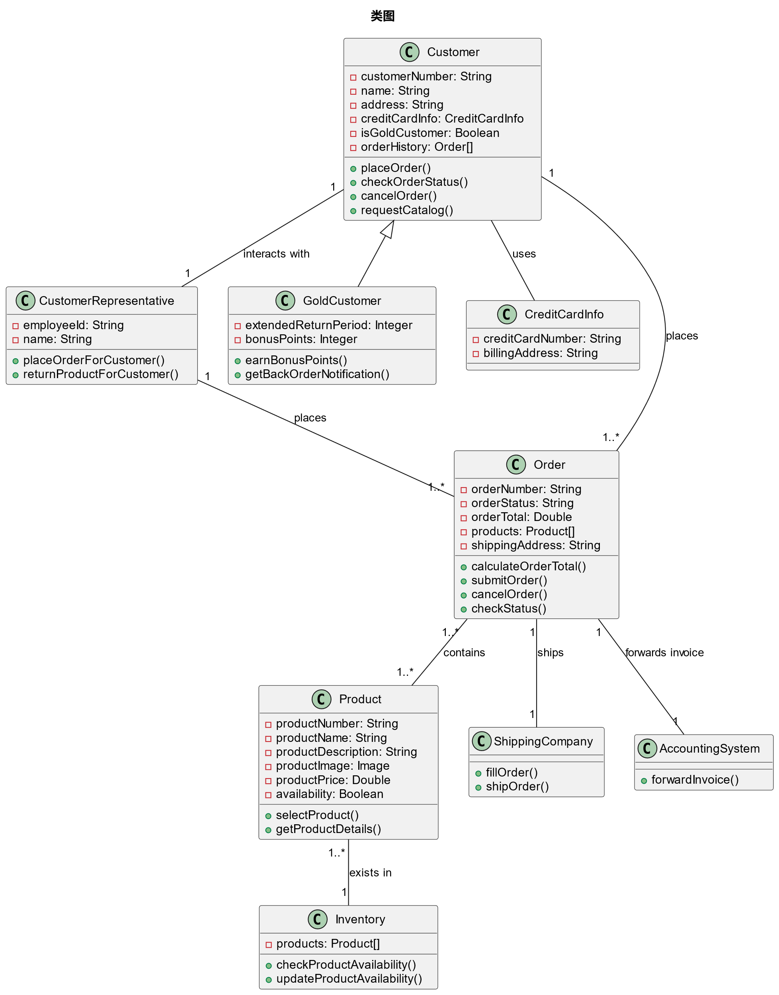

一些关键操作:

1. 客户：
   * 查看订单状态：允许客户查询他们的订单状态。
   * 取消订单：允许客户取消他们的现有订单。
   * 请求目录：允许客户请求查看产品目录。
2. 产品：
   * 查看信息：查看产品的库存状态。
3. 订单：
   * 添加产品到订单：将一个或多个产品添加到订单中。
   * 删除产品从订单：从订单中删除一个或多个产品。
   * 提交订单：完成订单的创建过程，确认产品选择、数量、支付方式和送货地址。

(3) draw a UML Sequence Diagram for this particular scenario. You may use any software/solution domain objects if needed as well.

